

Server & Site(s) Installation Guide

This procedure should take less than 1 hour, and is possible to execute within 15 minutes.

WE STRONGLY ENCOURAGE YOUR REVIEW AND VALIDATE YOUR ENVIRONMENTAL PREREQUISITES PRIOR TO BEGINNING. FAILURE TO DO SO COULD RESULT IN ADDITIONAL TIME. THANK YOU

For more information or if you need help, please contact your designated representative:
James Venus | jvenus@oxcyon.com

- 440-239-8619
- 440-239-8621

Centralpoint Installation Guide CONFIDENTIAL 1
Step One: Preparing your environment

YOU WILL NEEED A TOTAL OF 04 ‘STATIC’ IP ADRESSES

(Note: If you want to support multiple client sites, you will need one additional for each.)

1 – Master Management Console (Used to access the Server)
1 – Primary Development Site (Used to access your development site)

1 – Primary Quality Control Site (Used to access your Staging/QC site)

1 – For each Client Site (Used to access any of your individual client sites)

EXAMPLE OF HOW TO CONFIGURE THE DNS FOR EACH ‘STATIC’ IP ADDRESS:
Master Management Console – master.domain.com
Primary Development Site – dev.domain.com

Primary Quality Control Site – qc.domain.com

Client Site – clientsitename.domain.com

YOU MUST HAVE THE FOLLOWING ITEMS INSTALLED ON THE WEB SERVER

- Internet Information Services (IIS) Manager
- SMTP Server - IMPORTANT: Set Relay Server to ‘127.0.0.1’
- ASP.NET State Server (Administrative Tools / Services)
- Microsoft .NET Framework 4.0 ASP.NET Installation http://www.microsoft.com/downloads/info.aspx?na=41&srcfamilyid=9cfb2d51-5ff4-4491-b0e5-b386f32c0992&srcdisplaylang=en&u=http%3a%2f%2fdownload.microsoft.com%2fdownload%2f1%2fB%2fE %2f1BE39E79-7E39-46A3-96FF-047F95396215%2fdotNetFx40_Full_setup.exe

- Microsoft .NET Framework 4.5.2 (Web Installer) - http://www.microsoft.com/en-us/download/details.aspx?id=42643

- Microsoft SQL Must be installed (The web server and database can be in separate locations)

  - *We Recommend Microsoft SQL Server 2014 Standard or Enterprise, but you are free to install using:

  - Microsoft SQL Server 2012 Standard or Enterprise Edition Server

  - Microsoft SQL Server 2008R2 Standard or Enterprise Edition Server

BE SURE TO HAVE THE FOLLOWING INSTALLED OR CONFIGURED:

a.) Your server must be running Microsoft .NET Framework 4.5.2 (Web Installer) - http://www.microsoft.com/en-us/download/details.aspx?id=42643

b.) Install Access Database Engine https://www.microsoft.com/en-ca/download/details.aspx?id=13255

(This is required, as Centralpoint’s data transfer tools support Access (and others), but it is nice to have it installed should anyone be imported from Access in the future).

c.) SERVER Access must be given to: http://www.aranon.net/Verify.aspx . The web server must have access to the Centralpoint servers to download the latest installation package. Please verify that you have the required access by loading the following URL in Microsoft Internet Explorer: This access is to check and download newly updated features of Centralpoint (from Oxcyon).

d.) Grant RDP Access (VPN Access) to the server so that Oxcyon may assist in the installation for you and be able to troubleshoot any items as well. This is NOT a REQUIRED step, but is highly recommended by Oxcyon so that we may be able to access your environment should you need assistance.

e.) You must have administrative privileges on this server. If you do not, please request administrative privileges before continuing, or ask an administrator to conduct the installation in your behalf.

Centralpoint Installation Guide CONFIDENTIAL 2
Step Two – Execute the Installation file

This link will be provided to you by Oxcyon staff, which is the ‘msi’ or executable to begin the installation of Centralpoint locally (on premise). The Installation wizard will appear, prompting you along the way. If you need the link, contact your representative

Centralpoint Installation Wizard - Screen #1

Simply click Next (bottom right of prompt) to begin the installation. Be sure to double check that your environment is set up properly (Page 2 of this guide)
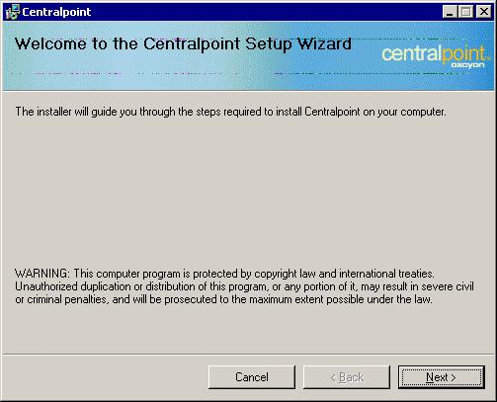

Centralpoint Installation Guide CONFIDENTIAL 3
Centralpoint Installation Wizard - Screen #2
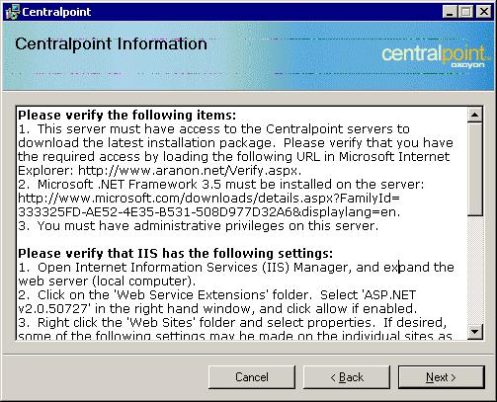

Please verify the following items:

- This server must have access to the Centralpoint servers to download the latest installation package. Please verify that you have the required access by loading the following URL in Microsoft Internet Explorer: http://www.aranon.net/Verify.aspx

- Microsoft .NET Framework 4.0 must be installed on the server: http://www.microsoft.com/downloads/info.aspx?na=41&srcfamilyid=9cfb2d51-5ff4-4491-b0e5-
b386f32c0992&srcdisplaylang=en&u=http%3a%2f%2fdownload.microsoft.com%2fdownload%2f1%2fB%2fE %2f1BE39E79-7E39-46A3-96FF-047F95396215%2fdotNetFx40_Full_setup.exe

- IMPORTANT!

a.) You must have administrative privileges on this server.

b.) Use the Server Manager to install the Web Server Role and the Application Development: ASP.NET Role Service, and be sure to include any related requirements when prompted.

c.) Manually stop the default web site in IIS when installing the Master on localhost port 80.

Due to the dynamic nature of Centralpoint the installation process must download a current installation package. This can be time consuming and may cause the progress indicator to stop while the download is in progress. Please be patient while the installation is in progress.

Note: If Microsoft SQL Server 2008R2 is not installed on the same computer on which you are currently installing Centralpoint you must first manually create the installation folder (i.e. C:/Centralpoint) then give SQL Server permission to restore database backups which will be placed in subdirectories of this folder.

Centralpoint Installation Guide CONFIDENTIAL 4
Centralpoint Installation Wizard - Screen #3

You will then be asked to read the license agreement thoroughly and then accept the terms of the license before you can proceed.
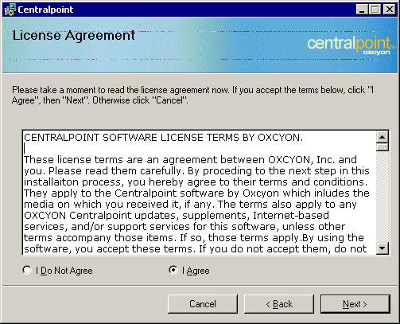

Centralpoint Installation Wizard - Screen #4

During this step you will enter your name and Organization’s name before you can proceed
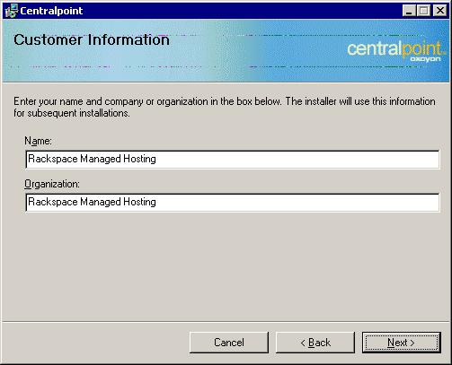

Centralpoint Installation Guide CONFIDENTIAL 5
Centralpoint Installation Wizard - Screen #5

Enter the IP Address to use for the Master web site: (Master Management Console). This will be the Static IP address that you have allocated (in preparing your environment) for the Master Management Console.
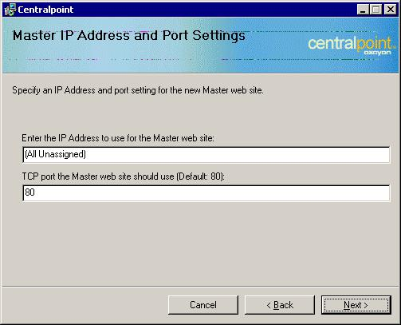

Centralpoint Installation Wizard - Screen #6

Note: Please specify the location on the server where you want all the Centralpoint files to be place this is determined
how your server was configured. Example: E:\Centralpoint
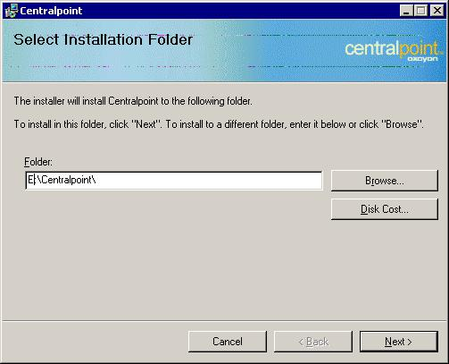

Centralpoint Installation Guide CONFIDENTIAL 6
Centralpoint Installation Wizard - Screen #7

It will confirm at this step that you are prepared to run the installer
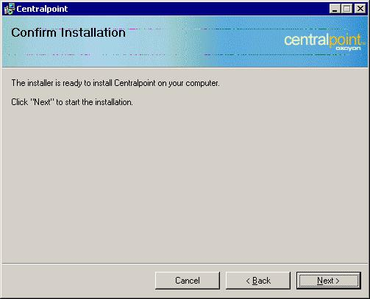

Centralpoint Installation Wizard - Screen #8

The installer will confirm when it has completed.
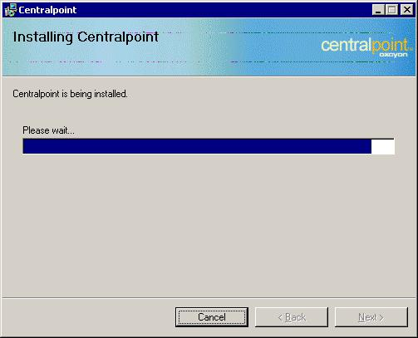

Centralpoint Installation Guide CONFIDENTIAL 7
Centralpoint Installation Wizard - Screen #9

After the installation is complete, the following screen will appear.

This screen is actually the MMC or Master Management Console and will be asking you questions to set it up for your first use.

1.) It will ask you to input the ADMINISTRATOR USERNAME and PASSWORD (See earlier, where we recommend that you have administrator privileges).

2.) It will also ask you to enter the STATIC IP address that you have assigned for your DEVELOPMENT WEBSITE (This is the website that is reserved for any local development you may do).

3.) Once completed, SCROLL TO THE BOTTOM OF THE PAGE AND CLICK NEXT).
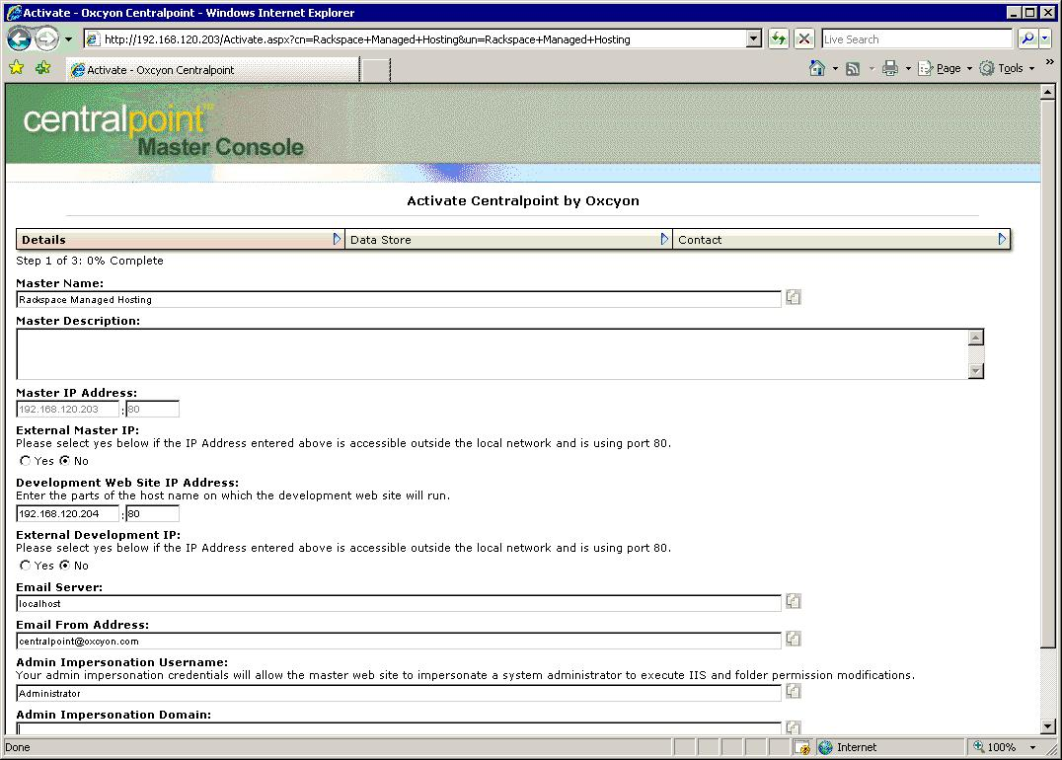

Centralpoint Installation Guide CONFIDENTIAL 8
Centralpoint Installation Wizard - Screen #10

During this step. You will need to:

1.) Enter in the full path of the PARENT DIRECTORY or DATA DIRECTORY for SQL into the field entitled ‘Data Folder’ (as seen in the screen below).

This allows Centralpoint to know ‘where’ SQL’ lives and how to interact with it. You may enter a parent directory which is not the same as the web server (in the event your database server and web server are being managed separately (or independently)

2.) You will also need to enter in the location of the FULL TEXT CATALOG FOLDER in the field named the same. This is a folder found within SQL, which manages the full text indexing.

This allows Centralpoint to know ‘where’ to instruct any indexing (and frequency of index which is being run against SQL)
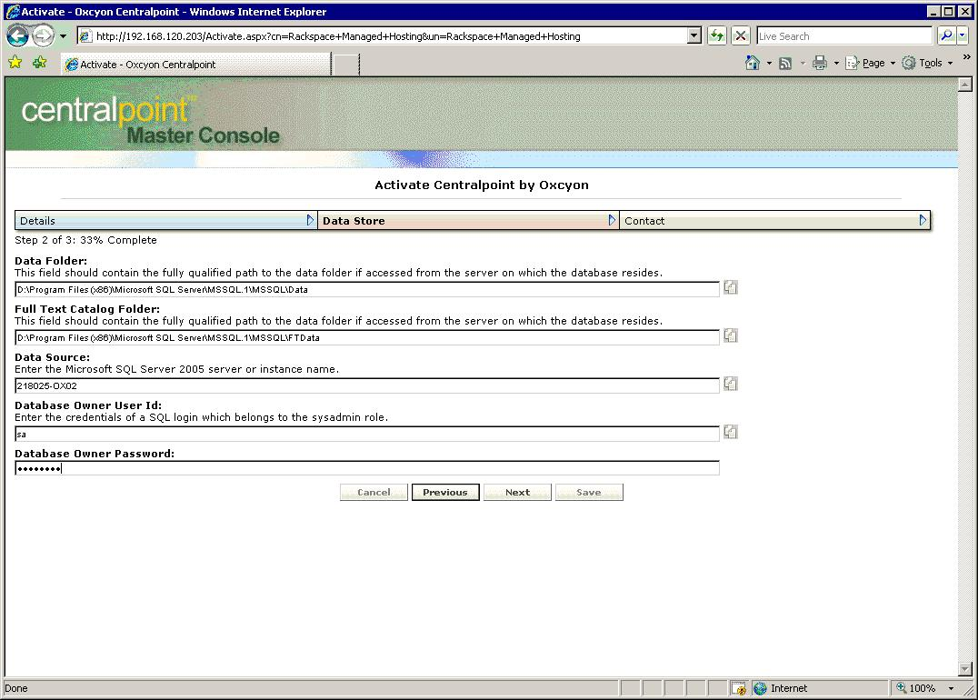

Centralpoint Installation Guide CONFIDENTIAL 9

3.) | You will need to add Microsoft Server instance name in the DATA SOURCE field. This is the name
 | identified in SQL. This is the name of the SQL Installation (or instance) that you have living in your
 | environment. If you do not know what it is, you can open SQL Management Studio, log in with your
 | credentials, that you used to originally install SQL with, once you log in, you will see the name of the SQL
 | instance. This will be the name you will use to copy and paste into this field.
4.) | You will then need to enter in ‘sa’ and password in to the field called DATABASE OWNER USER ID. The
 | password for the database owner id (or ‘sa’) will be entered into the final field entitled DATABASE OWNER
 | PASSWORD
 | If you would like to create another account, instead of using sa, you may, however it needs to be a
 | DBA Owner Account ONLY (just like sa).
 | Some clients may question this step, but it is important to know this account is required and needed so
 | that Centralpoint (through its interface) can ‘create and deleting new database instances’ associated
 | when deploying new client sites. This step will save much time and effort for you later, as this process
 | is done programmatically (by Centralpoint).Additionally access to the Master Management Console is
 | password protected, so entering the database owner user ID, is safe within the MMC.
5.) | Finally, when completed filling out these fields, you will then click NEXT at the bottom of the screen.
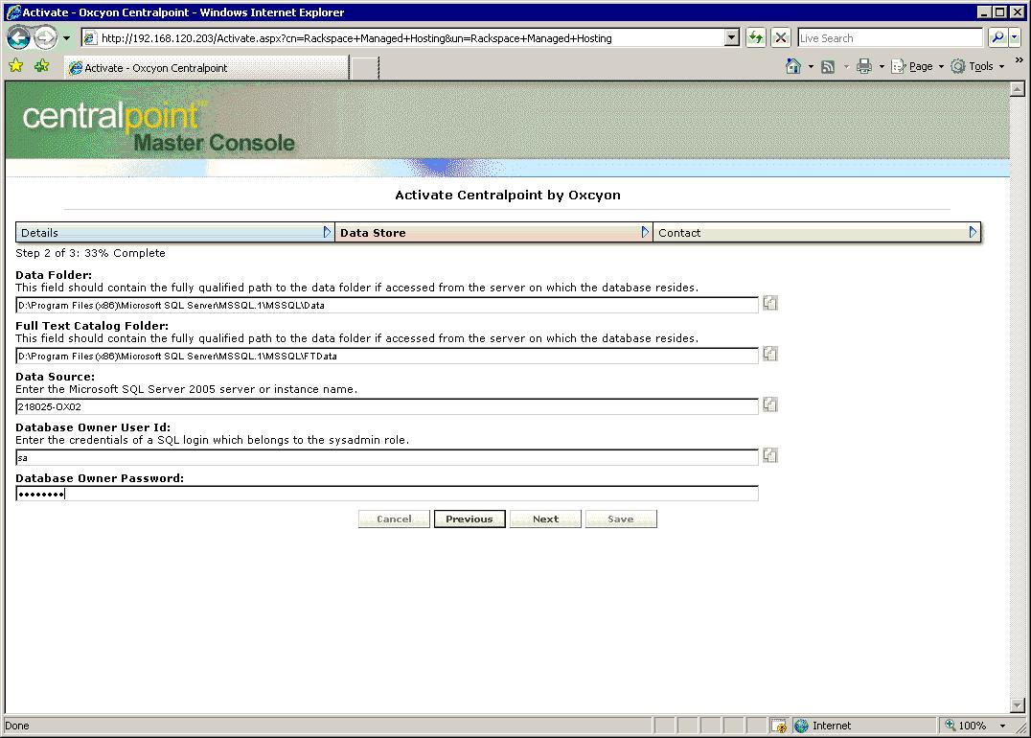

Centralpoint Installation Guide CONFIDENTIAL 10
Centralpoint Installation Wizard - Screen #11

Here you will enter in the name of your company, name, email and contact information needed to support your account. This will be the information of the user who will receive updates and notifications from Centralpoint (in our bi weekly update), and will be the primary point of contact for us to reach in the event you require server level support.

For the System Username and the System Password, you are free to create any one that you might want. This will be the username and password that you will need later to access the Master Management Console. After this step is completed (by you clicking on SAVE (at the bottom of the screen), information will be updated, and you will be returned to a log in screen (for the MMC – Master Management Console), where you will use your newly created username and password to log in.

NOTE: You may want to write down your username and password somewhere (or put it in as a new contact in Outlook) so that you may access it later.
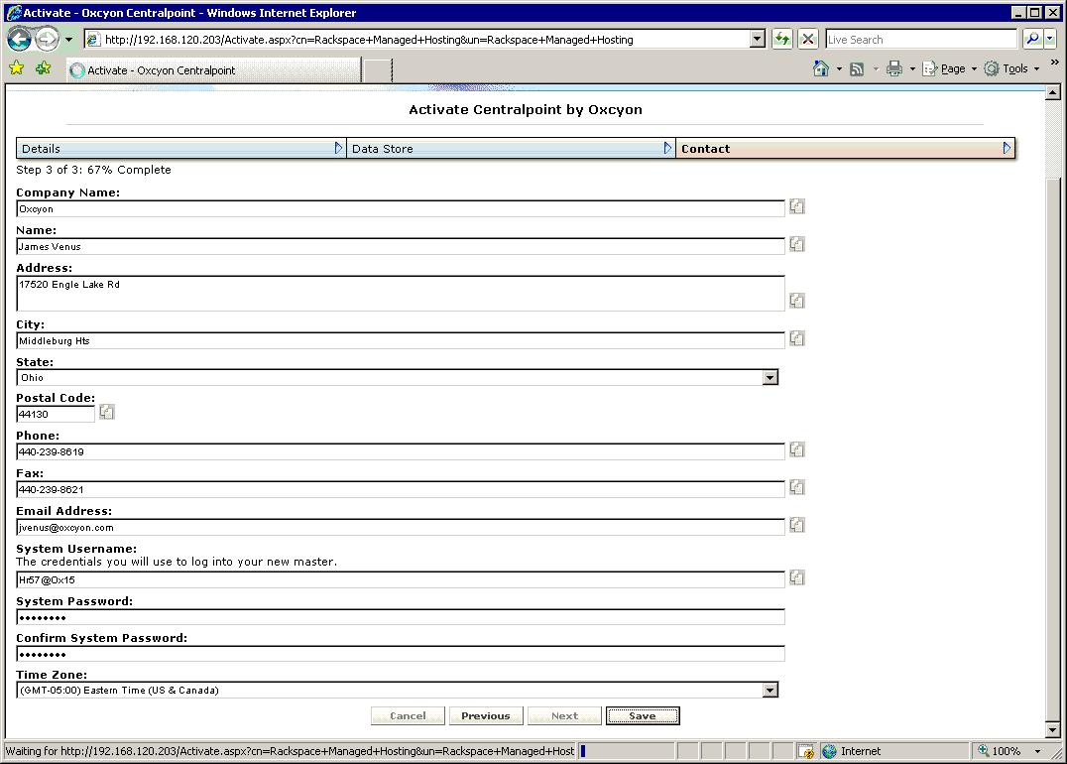

Centralpoint Installation Guide CONFIDENTIAL 11
Step Three – Access your Master Management Console

This is the log in page which you will be returned to, which lives under the Static IP designated for your Master Management Console.
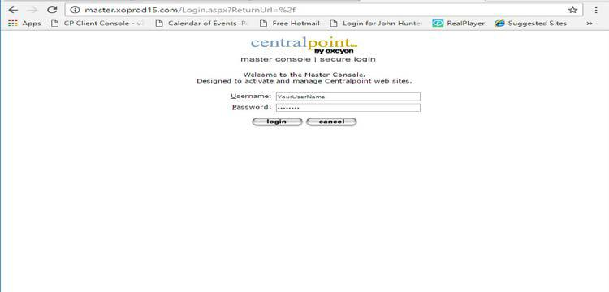

Once logged in you, you should see this screen, welcoming you for the first time your Master Management Console.
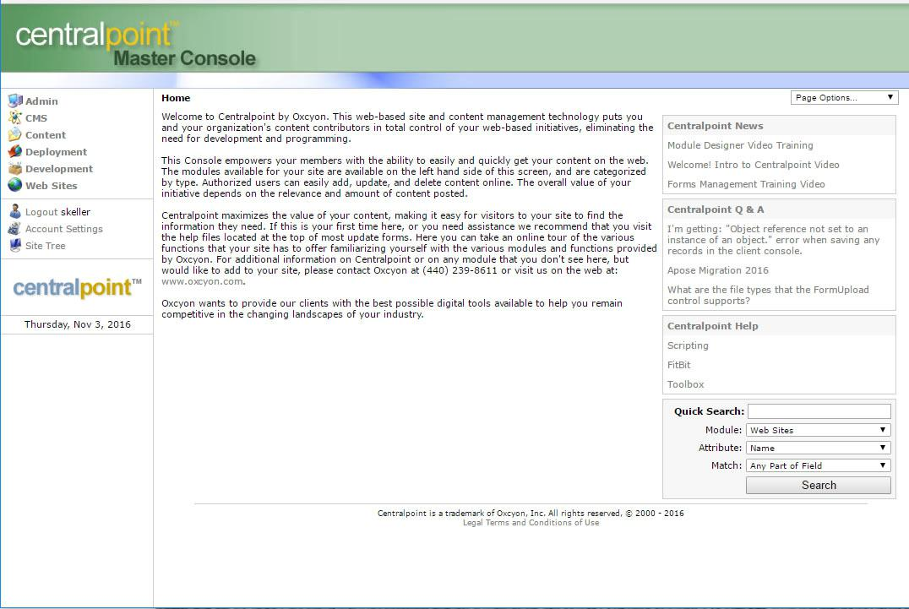

Centralpoint Installation Guide CONFIDENTIAL 12

Step Four – Creating your Centralpoint Website/Portal

1.) | To create a new Centralpoint Web Site (Portal) go to Deployment in the left menu.
2.) | You will then click on Web Sites (under Deployment), and then you will
3.) | Click on NEW (Upper Left Corner)
4.) | This will present you with a form to collect information about your new website:
- Enter the name of your Website (anything, it supports spaces)
- The system name will auto-populate (removing spaces).
- Enter the STATIC IP ADDRESS (reserved earlier for your Client Site). Enter port# 80 after the IP Address. (You are welcome to use port numbers outside of #80, but any other port would require your configuration internally within your network (or firewall).

- Within the field called HOST HEADER, please enter the name of your site, as it will appear within the URL. This does NOT need to be the same as what you have named it in the Master Management Console. You can use whatever prefix you like, ahead of the URL. Example: whatever.domain.com. BE SURE TO WRITE THIS DOWN
  - IMPORTANT NOTE: Make sure this an IP for this purpose and NOT currently in use by another application!!!
- You will want to select External = Yes, if this site is available to the outside world (or public). If this site is designated only for internal access (not available to the outside world) you would select ‘No’

- It will ask you what the PARENT WEBSITE is, and you will select DEVELOPMENT from the drop down list
  - NOTE: The reasoning here is that you may have multiple sites within the Centralpoint environment, and Centralpoint allows you to create ‘from’ any existing site which you may previously have created.
- When completed, click on SUBMIT below, and this will begin the site creation process. During this process you will see a progress screen showing you the following:
  - Creation of Website (within IIS)
  - Creation of Database (within MS/SQL)
  - Once completed, you will see ‘YOUR NEW SITE HAS BEEN CREATED’
- It will then prompt you to acknowledge the new site was created ‘Click OK’
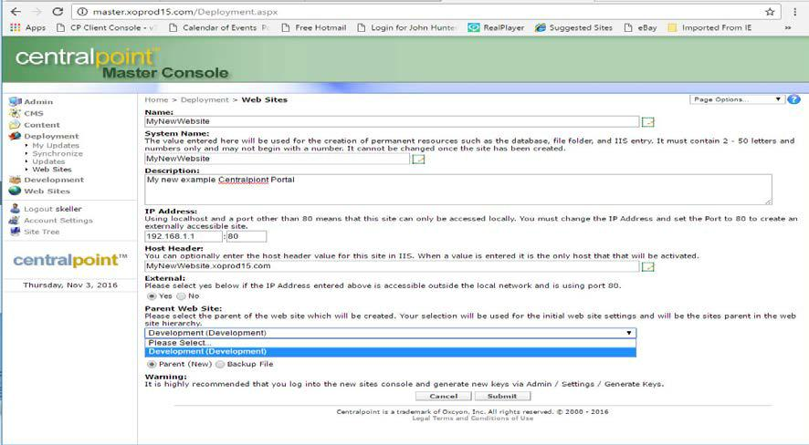

Centralpoint Installation Guide CONFIDENTIAL 13

Step 5 – Accessing your newly created Website/Portal

1.) | To navigate to your new Centralpoint created website or portal, go to your browser of choice, and enter in
 | the the host header or name you have provided, in the previous step: whatever.domain.com
2.) | This will bring up your newly created Centralpoint Website Portal.
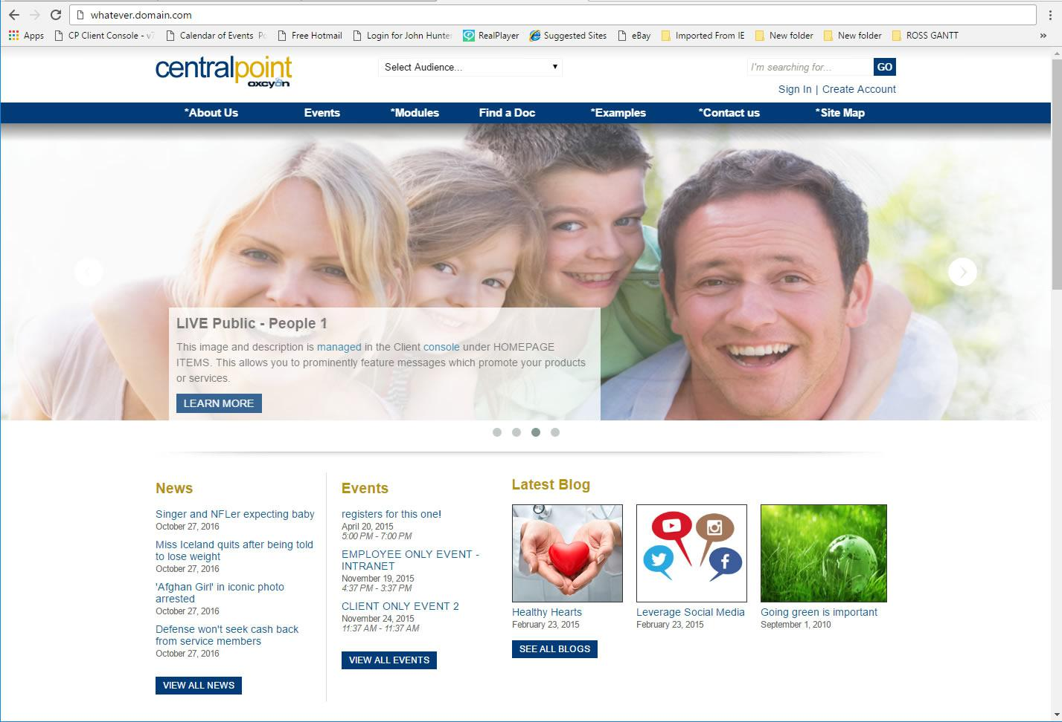

3.) | Here you can navigate your new site. This site will be configured with all of the available modules and/or
 | functions of Centralpoint. We encourage to familiarize yourself with the many navigation options, each
 | which feature different modules.
4.) | Other areas to explore:
- Search
- Site Map
- Events
- Sign In
- General study over the design, and its’ responsiveness

Centralpoint Installation Guide CONFIDENTIAL 14
Step 6- Accessing your new website’s Client Console

1.) To access the CLIENT CONSOLE, or administrative interface for your new website/portal,
- please go to : whatever.domain.com/console

2.) To access, enter the username/password that you have created for yourself in the previous step (or that you written down, and why we recommend it).
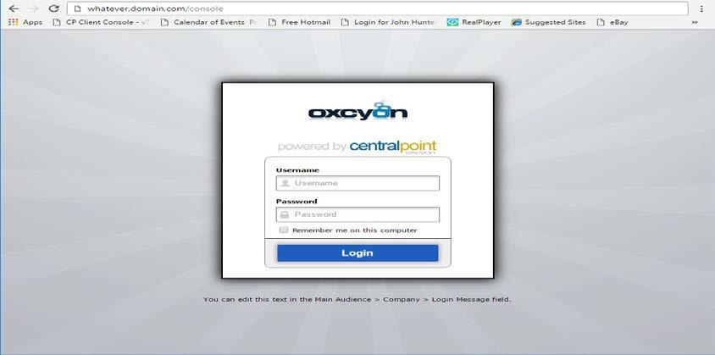

3.) This will return you to the CLIENT CONSOLE, where all content and information are managed for your Centralpoint Website/Portal. We encourage you to explore the many features of the console, and invite you to contact your representative for any training needed for site set up. For a narrated tour of this Client Console to familiarize you with it, please see this Video Tutorial.
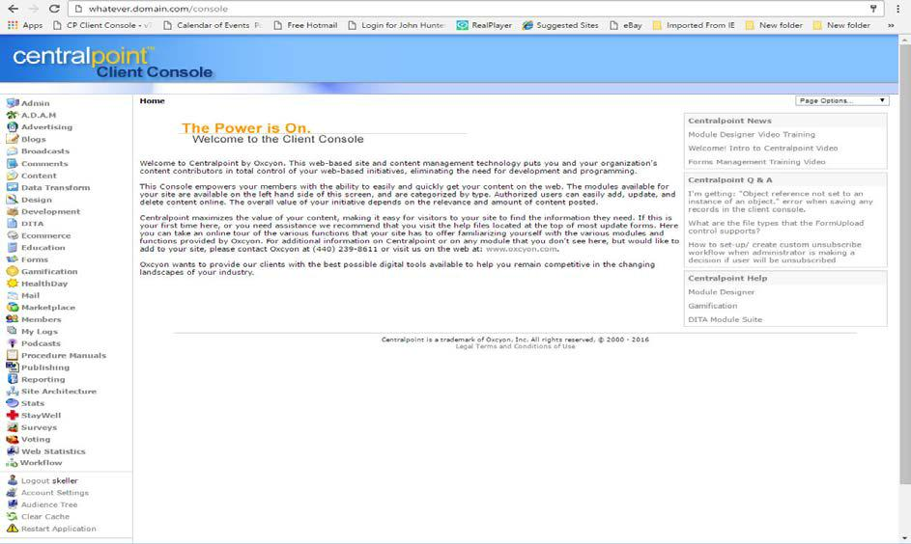

Centralpoint Installation Guide CONFIDENTIAL 15

